

**ARAB ACADEMY FOR SCIENCE, TECHNOLOGY AND MARITIME TRANSPORT (AASTMT)**

**College of Engineering and Technology**

**Car maintenance center**

**Mohamed Mosleh 19106762**

**Submitted to**

**Arab Academy for Science, Technology and Maritime Transport**

Project description:

The objective of this project is to do a database management system for a Cars maintenance center. At first, we decided to go as a group to do some visits for some centers to ask some questions and to start to collect the data we need for the project and to know some of the problems that faces these centers. So, these centers have some problems in organizing their work and have some serious problems internally with the arranging and organizing of the spare parts. So, our main focus was to fix all of these problems and make the work of this centers easier, well organized and more streamlined. The first things which our system changes in these centers are collecting the data of the customer. Data nowadays is very important for many reasons so the data that we collect is the name, phone number, age and car number. Every customer has its own unique ID and every car have its own ID so it makes it so much easier for the technical to identify which car belong to any customer and we did not stop just right there we wanted to make sure that the technical employees will not do any mistake or get confusion with the any car so we make the car color as a multivalued for every car besides the id that we give it so that no mistake will happen in the centers. Also, one of the problems that we faced was that when any customer has more than one car the employees start to give that customer more than one id and at sometimes, they won’t let him register more than one car so that causes many problems either with the space or the storage of the system and also effects on the experience of the customer with center which is of course a problem that nobody wants. Also, one of the problems we faced there was in organizing and arranging of the spare parts. The spare parts were not organized which caused a problem with loss some of it without knowing where it goes or anything about it so we stared to give it some ID. Every spare part has its own unique id which helps in organizing these is parts and helps in the storage and space of the system. To find a spare part you don’t need to write a whole name of it. all you need to do is to write the specific id for the part. These were some problems that we faced and how we deal with it but also while we were working on how to fix these problems, we started to analyze the information and data for this project requirement which include the entities, relationships and attribute then we started to develop a ERD design for the project (rough, final). We also started to do some logical deign for our attributes to consider which is the primary key and foreign key for each table. After finishing the analysis stage which is very important, we stared to write the SQL code on an oracle live. We started to use some SQL commands to create, alter, insert and delete tables

***Scope:***

Our database system and project isabout **car maintenance center** and it scoped for the people who have cars and want to made their maintenance with a very professional way by :

1. Adding customers information
2. Adding the customers car/s information
3. Printing a full service paper that includes the all maintenance and all changed parts in the car with the price
4. The technical is composed into electrician and mechanical
5. In payment we let the customer choose the way that he will pay with cash or visa-card

***-Introduction: Rough schema :***

***Final ER :***

***Mapping :***

**customer**

|  |  |  |  |  |  |  |
| --- | --- | --- | --- | --- | --- | --- |
| Customer_id | name | age | Phone_number |  |  |  |

**Car**

|  |  |  |  |  |  |  |
| --- | --- | --- | --- | --- | --- | --- |
| car_id | model | Plates_number | Customar_id |  |  |  |

**Technical**

|  |  |  |  |  |  |  |
| --- | --- | --- | --- | --- | --- | --- |
| Technical_id | salary | name |  |  |  |  |

**Spare parts**

|  |  |  |  |  |  |  |  |
| --- | --- | --- | --- | --- | --- | --- | --- |
| Part_id | name | price |  |  |  |  |  |

**Sales**

|  |  |  |  |  |  |  |
| --- | --- | --- | --- | --- | --- | --- |
| Sales_id | name | salary |  |  |  |  |

**Colour of car (multi-value)**

f.k p-k

|  |  |  |  |  |  |  |  |
| --- | --- | --- | --- | --- | --- | --- | --- |
| Car_id | colour |  |  |  |  |  |  |

**Service_paper (weak)**

p.k f.k

|  |  |  |  |  |  |  |  |  |
| --- | --- | --- | --- | --- | --- | --- | --- | --- |
| Service_id | Technical_id  --------------- |  |  |  |  |  |  |  |

**Payment (weak)**

p.k f-k f-k fk

|  |  |  |  |  |  |  |  |
| --- | --- | --- | --- | --- | --- | --- | --- |
| Payment_id | Sales_id | Car_id | Service_id |  |  |  |  |

**Use parts( m:n )**

f.k f.k

|  |  |  |  |  |  |  |
| --- | --- | --- | --- | --- | --- | --- |
| Technical_id | Parts_id |  |  |  |  |  |

***Car_technical***

|  |  |  |  |  |
| --- | --- | --- | --- | --- |
| ***Car_ID*** | ***Technical_id*** |  |  |  |

***Fk fk***

***SQL :***

***create table customer (***

***customer_id number not null ,***

***name varchar2(40) not null,***

***age number not null,***

***phone_number number not null,***

***PRIMARY KEY (customer_id)***

***);***

***create table car (***

***car_id number not null,***

***customer_id number not null,***

***model number not null,***

***plates_number varchar2(40) not null,***

***PRIMARY KEY (car_id) ,***

***FOREIGN KEY (customer_id) REFERENCES customer(customer_id)***

***);***

***create table technical (***

***technical_id number not null,***

***name varchar2(40) not null,***

***salary number not null,***

***PRIMARY KEY (technical_id)***

***);***

***create table spare_parts (***

***part_id number not null,***

***name varchar2(40) not null,***

***price number not null,***

***PRIMARY KEY (part_id)***

***);***

***create table service_paper (***

***service_id number not null,***

***car_id number not null,***

***customer_id number not null,***

***technical_id number not null,***

***name_of_service varchar2(40) not null,***

***date_of_today date,***

***PRIMARY KEY (service_id,car_id,customer_id,technical_id),***

***FOREIGN KEY (car_id) REFERENCES car(car_id),***

***FOREIGN KEY (customer_id) REFERENCES customer(customer_id),***

***FOREIGN KEY (technical_id) REFERENCES technical(technical_id)***

***);***

***create table used_spare_parts (***

***used_spare_parts_id number,***

***part_id number,***

***PRIMARY KEY (used_spare_parts_id,part_id),***

***FOREIGN KEY (part_id) REFERENCES spare_parts(part_id)***

***);***

***create table sales (***

***sales_id number not null,***

***invoice_id number not null,***

***name varchar2(40) not null***

***);***

***ALTER TABLE sales***

***ADD CONSTRAINT sales PRIMARY KEY (sales_id,invoice_id);***

***ALTER TABLE sales***

***ADD CONSTRAINT sales FOREIGN KEY (invoice_id);***

***create table invoices (***

***invoice_id number not null,***

***sales_id number not null,***

***car_id number not null,***

***primary key (invoice_id, sales_id, car_id)***

***);***

***/************************************************Creating tables************************************************/***

***create table customer ( customer_id number not null ,name varchar2(40) not null, age number not null, phone_number number not null);***

***create table car (car_id number not null,customer_id number not null, model number not null,plates_number varchar2(40) not null);***

***create table technical (technical_id number not null,name varchar2(40) not null,salary number not null);***

***create table service_paper (service_id number not null,car_id number not null,customer_id number not null,technical_id number not null,name_of_service varchar2(40) not null,date_of_today date);***

***create table spare_parts ( part_id number not null,name varchar2(40) not null,price number not null);***

***create table sales (sales_id number not null,name varchar2(40) not null);***

***create table colour_of_car(car_id number not null,colour varchar2(40));***

***create table payment(payment_id number not null,car_id number not null,sales_id number not null);***

***create table use_parts(technical_id number not null, part_id number not null);***

***/*************************************************Altering tables************************************************/***

***ALTER TABLE customer ADD PRIMARY KEY (customer_id);***

***ALTER TABLE customer***

***ADD email varchar(255);***

***ALTER TABLE customer***

***DROP COLUMN age;***

***ALTER TABLE customer***

***ADD b_date date;***

***------------------------------------------------------------***

***ALTER TABLE car ADD PRIMARY KEY (car_id);***

***ALTER TABLE car ADD FOREIGN KEY (customer_id) REFERENCES customer(customer_id);***

***------------------------------------------------------------***

***ALTER TABLE technical ADD PRIMARY KEY (technical_id);***

***------------------------------------------------------------***

***ALTER TABLE service_paper ADD PRIMARY KEY (service_id,technical_id);***

***ALTER TABLE service_paper ADD FOREIGN KEY (car_id) REFERENCES car(car_id);***

***ALTER TABLE service_paper ADD FOREIGN KEY (technical_id) REFERENCES technical(technical_id);***

***ALTER TABLE service_paper ADD FOREIGN KEY (service_id) REFERENCES service_paper(service_id);***

***ALTER TABLE service_paper ADD FOREIGN KEY (customer_id) REFERENCES customer(customer_id);***

***------------------------------------------------------------***

***ALTER TABLE spare_parts ADD PRIMARY KEY (part_id);***

***------------------------------------------------------------***

***ALTER TABLE sales ADD PRIMARY KEY (sales_id);***

***------------------------------------------------------------***

***alter table colour_of_car ADD PRIMARY KEY (colour);***

***ALTER TABLE colour_of_car ADD FOREIGN KEY (car_id) REFERENCES car(car_id);***

***------------------------------------------------------------***

***alter table payment ADD PRIMARY KEY (payment_id,sales_id);***

***ALTER TABLE payment ADD FOREIGN KEY (sales_id) REFERENCES sales(sales_id);***

***------------------------------------------------------------***

***ALTER TABLE use_parts ADD FOREIGN KEY (technical_id) REFERENCES technical(technical_id);***

***ALTER TABLE use_parts ADD FOREIGN KEY (part_id) REFERENCES spare_parts(part_id);***

***------------------------------------------------------------***

***/************************************************customer table************************************************/***

***insert into customer values(1 ,'mohamed mosleh' ,01023432792,'Ali_Ahmad@live.com');***

***insert into Customer values(2 ,'Aafreen Kader' ,01022458545,'Aafreen_Kader@live.com' , date '2000-1-1');***

***insert into Customer values(3 ,'Sadiq Arshad' ,01022458545,'Sadiq_Arshad@live.com' , date '2000-5-6');***

***insert into Customer values(4 ,'Ghazi Haq' ,01022458545,'Ghazi_Haq@live.com' , date '2005-9-11');***

***insert into Customer values(5 ,'Ghayda Karam' ,01022458545,'Ghayda_Karam@live.com' , date '1999-6-12');***

***insert into Customer values(6 ,'Jerick Safar' ,01022458545,'Jerick_Safar@live.com' , date '2003-1-1');***

***insert into Customer values(7 ,'Abdullah Muhammad' ,01022458545,'Abdullahi_Muhammad@live.com' , date '1998-1-9');***

***insert into Customer values(8 ,'Qasiba Mourad' ,01022458545,'Qasiba_Mourad@live.com' , date '2001-8-1');***

***insert into Customer values(9 ,'Wahid Srour' ,01022458545,'Wahid_Srour@live.com' , date '2003-1-12');***

***insert into Customer values(10 ,'Zeena Mahmood' ,01022458545,'Zeena_Mahmood@live.com' , date '2002-1-7');***

***insert into Customer values(11 ,'Mahmud Shaban' ,01022458545,'Mahmud_Shaban@live.com' , date '2004-9-1');***

***insert into Customer values(12 ,'Ahsan Ramin' ,01022458545,'Ahsan_Ramin@live.com' , date '2006-6-7');***

***insert into Customer values(13 ,'Jihad Asmar' ,01022458545,'Jihad_Asmar@live.com' , date '2005-9-12');***

***insert into Customer values(14 ,'Wali Halim' ,01022458545,'Wali_Halim@live.com' , date '2003-1-1');***

***insert into Customer values(15 ,'Hamal Adel' ,01022458545,'Hamal_Adel@live.com' , date '2001-9-1');***

***insert into Customer values(16 ,'Riham Siddiqi' ,01022458545,'Riham_Siddiqi@live.com' , date '2003-12-11');***

***insert into Customer values(17 ,'Fatin Sadri' ,01022458545,'Fatin_Sadri@live.com' , date '2006-10-9');***

***insert into Customer values(18 ,'Nasra Amen' ,01022458545,'Nasra_Amen@live.com' , date '2005-1-1');***

***insert into Customer values(19 ,'Fadi Faris' ,01022458545,'Fadi_Faris@live.com' , date '2009-10-12');***

***insert into Customer values(20 ,'Timin Nazir' ,01022458545,'Timin_Nazir@live.com' , date '2004-10-11');***

***insert into Customer values(21 ,'Nadim Elbaz' ,01022458545,'Nadim_Elbaz@live.com' , date '2006-5-1');***

***insert into Customer values(22 ,'Radwan Khan' ,01022458545,'Radwan_Khan@live.com' , date '2001-1-2');***

***insert into Customer values(23 ,'Abbas Zadeh' ,01022458545,'Abbas_Zadeh@live.com' , date '2003-6-1');***

***insert into Customer values(24 ,'Rawdah Taha' ,01022458545,'Rawdah_Taha@live.com' , date '2001-11-11');***

***insert into Customer values(25 ,'Muhsin Nazir' ,01022458545,'Muhsin_Nazir@live.com' , date '2003-3-10');***

***insert into Customer values(26 ,'Malik Aziz' ,01022458545,'Malik_Aziz@live.com' , date '2004-4-5');***

***insert into Customer values(27 ,'Mustafa Ammar' ,01022458545,'Mustafa_Ammar@live.com' , date '2002-9-9');***

***insert into Customer values(28 ,'Zahia Jabbar' ,01022458545,'Zahia_Jabbar@live.com' , date '2006-11-12');***

***insert into Customer values(29 ,'Yasin Mansoor' ,01022458545,'Yasin_Mansoor@live.com' , date '2007-9-6');***

***insert into Customer values(30 ,'Qamar Sultan' ,01022458545,'Qamar_Sultan@live.com' , date '2009-6-9');***

***insert into Customer values(31 ,'Samia Jama' ,01022458545,'Samia_Jama@live.com' , date '2006-5-1');***

***insert into Customer values(32 ,'Nuha Salman' ,01022458545,'Nuha_Salman@live.com' , date '2005-5-9');***

***insert into Customer values(33 ,'Shakir Tariq' ,01022458545,'Shakir_Tariq@live.com' , date '2003-3-11');***

***insert into Customer values(34 ,'Basel Hamady' ,01022458545,'Basel_Hamady@live.com' , date '2005-12-9');***

***insert into Customer values(35 ,'Raziqa Amiri' ,01022458545,'Raziqa_Amiri@live.com' , date '2000-1-1');***

***insert into Customer values(36 ,'Yamana Sadri' ,01022458545,'Yamana_Sadri@live.com' , date '2006-6-11');***

***insert into Customer values(37 ,'Nuha Ismail' ,01022458545,'Nuha_Ismail@live.com' , date '2005-9-11');***

***insert into Customer values(38 ,'Hatim Moussa' ,01022458545,'Hatim_Moussa@live.com' , date '2008-4-8');***

***insert into Customer values(39 ,'Siraj Allee' ,01022458545,'Siraj_Allee@live.com' , date '2001-12-3');***

***insert into Customer values(40 ,'Kalid Abed' ,01022458545,'Kalid_Abed@live.com' , date '2006-9-12');***

***insert into Customer values(41 ,'Shareef Nagi' ,01022458545,'Shareef_Nagi@live.com' , date '2005-9-7');***

***insert into Customer values(42 ,'Fanan Shahan' ,01022458545,'Fanan_Shahan@live.com' , date '2003-5-12');***

***insert into Customer values(43 ,'Yahya Baddour' ,01022458545,'Yahya_Baddour@live.com' , date '2004-6-9');***

***insert into Customer values(44 ,'Lattef Abdalla' ,01022458545,'Lattef_Abdalla@live.com' , date '2003-4-4');***

***insert into Customer values(45 ,'Muhammad Masri' ,01022458545,'Muhammad_Masri@live.com' , date '2008-2-9');***

***insert into Customer values(46 ,'Rabah Habeeb' ,01022458545,'Rabah_Habeeb@live.com' , date '2006-3-9');***

***insert into Customer values(47 ,'Yasin Fahmy' ,01022458545,'Yasin_Fahmy@live.com' , date '2009-9-8');***

***insert into Customer values(48 ,'Sameer Mina' ,01022458545,'Sameer_Mina@live.com' , date '2007-7-3');***

***insert into Customer values(49 ,'Nasra Shaban' ,01022458545,'Nasra_Shaban@live.com' , date '2000-9-7');***

***insert into Customer values(50 ,'Najib Radi' ,01022458545,'Najib_Radi@live.com' , date '2003-10-6');***

***select* from customer***

***/************************************************car table************************************************/***

***insert into car values(1 ,1 ,2003,' عنب 123' );***

***INSERT INTO `car` (`car_id`, `customer_id`, `model`,`plates_number`) VALUES***

***(2, 2, 2003,'ا ه ه 222'),***

***(2, 'ALFA', 'Alfa Romeo'),***

***(3, 'AMC', 'AMC'),***

***(4, 'ASTON', 'Aston Martin'),***

***(5, 'AUDI', 'Audi'),***

***(6, 'AVANTI', 'Avanti'),***

***(7, 'BENTL', 'Bentley'),***

***(8, 'BMW', 'BMW'),***

***(9, 'BUICK', 'Buick'),***

***(10, 'CAD', 'Cadillac'),***

***(11, 'CHEV', 'Chevrolet'),***

***(12, 'CHRY', 'Chrysler'),***

***(13, 'DAEW', 'Daewoo'),***

***(14, 'DAIHAT', 'Daihatsu'),***

***(15, 'DATSUN', 'Datsun'),***

***(16, 'DELOREAN', 'DeLorean'),***

***(17, 'DODGE', 'Dodge'),***

***(18, 'EAGLE', 'Eagle'),***

***(19, 'FER', 'Ferrari'),***

***(20, 'FIAT', 'FIAT'),***

***(21, 'FISK', 'Fisker'),***

***(22, 'FORD', 'Ford'),***

***(23, 'FREIGHT', 'Freightliner'),***

***(24, 'GEO', 'Geo'),***

***(25, 'GMC', 'GMC'),***

***(26, 'HONDA', 'Honda'),***

***(27, 'AMGEN', 'HUMMER'),***

***(28, 'HYUND', 'Hyundai'),***

***(29, 'INFIN', 'Infiniti'),***

***(30, 'ISU', 'Isuzu'),***

***(31, 'JAG', 'Jaguar'),***

***(32, 'JEEP', 'Jeep'),***

***(33, 'KIA', 'Kia'),***

***(34, 'LAM', 'Lamborghini'),***

***(35, 'LAN', 'Lancia'),***

***(36, 'ROV', 'Land Rover'),***

***(37, 'LEXUS', 'Lexus'),***

***(38, 'LINC', 'Lincoln'),***

***(39, 'LOTUS', 'Lotus'),***

***(40, 'MAS', 'Maserati'),***

***(41, 'MAYBACH', 'Maybach'),***

***(42, 'MAZDA', 'Mazda'),***

***(43, 'MCLAREN', 'McLaren'),***

***(44, 'MB', 'Mercedes-Benz'),***

***(45, 'MERC', 'Mercury'),***

***(46, 'MERKUR', 'Merkur'),***

***(47, 'MINI', 'MINI'),***

***(48, 'MIT', 'Mitsubishi'),***

***(49, 'NISSAN', 'Nissan'),***

***(50, 'OLDS', 'Oldsmobile'),***

***(51, 'PEUG', 'Peugeot'),***

***(52, 'PLYM', 'Plymouth'),***

***(53, 'PONT', 'Pontiac'),***

***(54, 'POR', 'Porsche'),***

***(55, 'RAM', 'RAM'),***

***(56, 'REN', 'Renault'),***

***(57, 'RR', 'Rolls-Royce'),***

***(58, 'SAAB', 'Saab'),***

***(59, 'SATURN', 'Saturn'),***

***(60, 'SCION', 'Scion'),***

***(61, 'SMART', 'smart'),***

***(62, 'SRT', 'SRT'),***

***(63, 'STERL', 'Sterling'),***

***(64, 'SUB', 'Subaru'),***

***(65, 'SUZUKI', 'Suzuki'),***

***(66, 'TESLA', 'Tesla'),***

***(67, 'TOYOTA', 'Toyota'),***

***(68, 'TRI', 'Triumph'),***

***(69, 'VOLKS', 'Volkswagen'),***

***(70, 'VOLVO', 'Volvo'),***

***(71, 'YUGO', 'Yugo');***

***select* from car***

***/************************************************Creating tables************************************************/***

***create table customer ( customer_id number not null ,name varchar2(40) not null, age number not null, phone_number number not null);***

***create table car (car_id number not null,customer_id number not null, model number not null,plates_number varchar2(40) not null);***

***create table technical (technical_id number not null,name varchar2(40) not null,salary number not null);***

***create table service_paper (service_id number not null,car_id number not null,customer_id number not null,technical_id number not null,name_of_service varchar2(40) not null,date_of_today date);***

***create table spare_parts ( part_id number not null,name varchar2(40) not null,price number not null);***

***create table sales (sales_id number not null,name varchar2(40) not null);***

***create table colour_of_car(car_id number not null,colour varchar2(40));***

***create table payment(payment_id number not null,car_id number not null,sales_id number not null);***

***create table use_parts(technical_id number not null, part_id number not null);***

***/*************************************************Altering tables************************************************/***

***ALTER TABLE customer ADD PRIMARY KEY (customer_id);***

***ALTER TABLE customer***

***ADD email varchar(255);***

***ALTER TABLE customer***

***DROP COLUMN age;***

***ALTER TABLE customer***

***ADD b_date date;***

***ALTER TABLE car ADD PRIMARY KEY (car_id);***

***ALTER TABLE car ADD FOREIGN KEY (customer_id) REFERENCES customer(customer_id);***

***ALTER TABLE technical ADD PRIMARY KEY (technical_id);***

***ALTER TABLE service_paper ADD PRIMARY KEY (service_id,technical_id);***

***ALTER TABLE service_paper ADD FOREIGN KEY (car_id) REFERENCES car(car_id);***

***ALTER TABLE service_paper ADD FOREIGN KEY (technical_id) REFERENCES technical(technical_id);***

***ALTER TABLE service_paper ADD FOREIGN KEY (service_id) REFERENCES service_paper(service_id);***

***ALTER TABLE service_paper ADD FOREIGN KEY (customer_id) REFERENCES customer(customer_id);***

***ALTER TABLE spare_parts ADD PRIMARY KEY (part_id);***

***ALTER TABLE sales ADD PRIMARY KEY (sales_id);***

***alter table colour_of_car ADD PRIMARY KEY (colour);***

***ALTER TABLE colour_of_car ADD FOREIGN KEY (car_id) REFERENCES car(car_id);***

***alter table payment ADD PRIMARY KEY (payment_id,sales_id);***

***ALTER TABLE payment ADD FOREIGN KEY (sales_id) REFERENCES sales(sales_id);***

***ALTER TABLE use_parts ADD FOREIGN KEY (technical_id) REFERENCES technical(technical_id);***

***ALTER TABLE use_parts ADD FOREIGN KEY (part_id) REFERENCES spare_parts(part_id);***

***------------------------------------------------------------***

***/************************************************customer table************************************************/***

***insert into customer values(1 ,'mohamed mosleh' ,01023432792,'Ali_Ahmad@live.com', date '2000-5-6');***

***insert into Customer values(2 ,'Aafreen Kader' ,01022458545,'Aafreen_Kader@live.com' , date '2000-1-1');***

***insert into Customer values(3 ,'Sadiq Arshad' ,01022458545,'Sadiq_Arshad@live.com' , date '2000-5-6');***

***insert into Customer values(4 ,'Ghazi Haq' ,01022458545,'Ghazi_Haq@live.com' , date '2005-9-11');***

***insert into Customer values(5 ,'Ghayda Karam' ,01022458545,'Ghayda_Karam@live.com' , date '1999-6-12');***

***insert into Customer values(6 ,'Jerick Safar' ,01022458545,'Jerick_Safar@live.com' , date '2003-1-1');***

***insert into Customer values(7 ,'Abdullah Muhammad' ,01022458545,'Abdullahi_Muhammad@live.com' , date '1998-1-9');***

***insert into Customer values(8 ,'Qasiba Mourad' ,01022458545,'Qasiba_Mourad@live.com' , date '2001-8-1');***

***insert into Customer values(9 ,'Wahid Srour' ,01022458545,'Wahid_Srour@live.com' , date '2003-1-12');***

***insert into Customer values(10 ,'Zeena Mahmood' ,01022458545,'Zeena_Mahmood@live.com' , date '2002-1-7');***

***insert into Customer values(11 ,'Mahmud Shaban' ,01022458545,'Mahmud_Shaban@live.com' , date '2004-9-1');***

***insert into Customer values(12 ,'Ahsan Ramin' ,01022458545,'Ahsan_Ramin@live.com' , date '2006-6-7');***

***insert into Customer values(13 ,'Jihad Asmar' ,01022458545,'Jihad_Asmar@live.com' , date '2005-9-12');***

***insert into Customer values(14 ,'Wali Halim' ,01022458545,'Wali_Halim@live.com' , date '2003-1-1');***

***insert into Customer values(15 ,'Hamal Adel' ,01022458545,'Hamal_Adel@live.com' , date '2001-9-1');***

***insert into Customer values(16 ,'Riham Siddiqi' ,01022458545,'Riham_Siddiqi@live.com' , date '2003-12-11');***

***insert into Customer values(17 ,'Fatin Sadri' ,01022458545,'Fatin_Sadri@live.com' , date '2006-10-9');***

***insert into Customer values(18 ,'Nasra Amen' ,01022458545,'Nasra_Amen@live.com' , date '2005-1-1');***

***insert into Customer values(19 ,'Fadi Faris' ,01022458545,'Fadi_Faris@live.com' , date '2009-10-12');***

***insert into Customer values(20 ,'Timin Nazir' ,01022458545,'Timin_Nazir@live.com' , date '2004-10-11');***

***insert into Customer values(21 ,'Nadim Elbaz' ,01022458545,'Nadim_Elbaz@live.com' , date '2006-5-1');***

***insert into Customer values(22 ,'Radwan Khan' ,01022458545,'Radwan_Khan@live.com' , date '2001-1-2');***

***insert into Customer values(23 ,'Abbas Zadeh' ,01022458545,'Abbas_Zadeh@live.com' , date '2003-6-1');***

***insert into Customer values(24 ,'Rawdah Taha' ,01022458545,'Rawdah_Taha@live.com' , date '2001-11-11');***

***insert into Customer values(25 ,'Muhsin Nazir' ,01022458545,'Muhsin_Nazir@live.com' , date '2003-3-10');***

***insert into Customer values(26 ,'Malik Aziz' ,01022458545,'Malik_Aziz@live.com' , date '2004-4-5');***

***insert into Customer values(27 ,'Mustafa Ammar' ,01022458545,'Mustafa_Ammar@live.com' , date '2002-9-9');***

***insert into Customer values(28 ,'Zahia Jabbar' ,01022458545,'Zahia_Jabbar@live.com' , date '2006-11-12');***

***insert into Customer values(29 ,'Yasin Mansoor' ,01022458545,'Yasin_Mansoor@live.com' , date '2007-9-6');***

***insert into Customer values(30 ,'Qamar Sultan' ,01022458545,'Qamar_Sultan@live.com' , date '2009-6-9');***

***insert into Customer values(31 ,'Samia Jama' ,01022458545,'Samia_Jama@live.com' , date '2006-5-1');***

***insert into Customer values(32 ,'Nuha Salman' ,01022458545,'Nuha_Salman@live.com' , date '2005-5-9');***

***insert into Customer values(33 ,'Shakir Tariq' ,01022458545,'Shakir_Tariq@live.com' , date '2003-3-11');***

***insert into Customer values(34 ,'Basel Hamady' ,01022458545,'Basel_Hamady@live.com' , date '2005-12-9');***

***insert into Customer values(35 ,'Raziqa Amiri' ,01022458545,'Raziqa_Amiri@live.com' , date '2000-1-1');***

***insert into Customer values(36 ,'Yamana Sadri' ,01022458545,'Yamana_Sadri@live.com' , date '2006-6-11');***

***insert into Customer values(37 ,'Nuha Ismail' ,01022458545,'Nuha_Ismail@live.com' , date '2005-9-11');***

***insert into Customer values(38 ,'Hatim Moussa' ,01022458545,'Hatim_Moussa@live.com' , date '2008-4-8');***

***insert into Customer values(39 ,'Siraj Allee' ,01022458545,'Siraj_Allee@live.com' , date '2001-12-3');***

***insert into Customer values(40 ,'Kalid Abed' ,01022458545,'Kalid_Abed@live.com' , date '2006-9-12');***

***insert into Customer values(41 ,'Shareef Nagi' ,01022458545,'Shareef_Nagi@live.com' , date '2005-9-7');***

***insert into Customer values(42 ,'Fanan Shahan' ,01022458545,'Fanan_Shahan@live.com' , date '2003-5-12');***

***insert into Customer values(43 ,'Yahya Baddour' ,01022458545,'Yahya_Baddour@live.com' , date '2004-6-9');***

***insert into Customer values(44 ,'Lattef Abdalla' ,01022458545,'Lattef_Abdalla@live.com' , date '2003-4-4');***

***insert into Customer values(45 ,'Muhammad Masri' ,01022458545,'Muhammad_Masri@live.com' , date '2008-2-9');***

***insert into Customer values(46 ,'Rabah Habeeb' ,01022458545,'Rabah_Habeeb@live.com' , date '2006-3-9');***

***insert into Customer values(47 ,'Yasin Fahmy' ,01022458545,'Yasin_Fahmy@live.com' , date '2009-9-8');***

***insert into Customer values(48 ,'Sameer Mina' ,01022458545,'Sameer_Mina@live.com' , date '2007-7-3');***

***insert into Customer values(49 ,'Nasra Shaban' ,01022458545,'Nasra_Shaban@live.com' , date '2000-9-7');***

***insert into Customer values(50 ,'Najib Radi' ,01022458545,'Najib_Radi@live.com' , date '2003-10-6');***

***select* from customer***

***/************************************************car table************************************************/***

***insert into car values(1 ,1 ,2003,' عنب 123');***

***insert into car values(2 ,3 ,2014,' عسب 444');***

***insert into car values(3 ,2 ,2012,' عنع 785');***

***insert into car values(4 ,2 ,2010,' ينب 524');***

***insert into car values(5 ,2 ,2001,'ةنب 148');***

***insert into car values(6 ,5 ,2009,' اوه 625');***

***insert into car values(7 ,7 ,2019,' واو 252');***

***insert into car values(8 ,8 ,2020,' جود 412');***

***insert into car values(9 ,20 ,2011,' جوب 999');***

***insert into car values(10 ,9 ,2077,' نيس 286');***

***insert into car values(11 ,5 ,2088,' مو 784');***

***insert into car values(12 ,5 ,2039,' صلا 115');***

***insert into car values(13 ,7 ,2022,' نور 225');***

***insert into car values(14 ,9 ,2005,' عين 114');***

***insert into car values(15 ,10 ,2007,' اوي 336');***

***select* from car***

***/************************************************technical table************************************************/***

***insert into technical values(1 ,'mohamed mosleh' ,2500);***

***insert into Technical values(2 ,'Aafreen Kader' ,2000);***

***insert into Technical values(3 ,'Sadiq Arshad' ,1000);***

***insert into Technical values(4 ,'Ghazi Haq' ,3000);***

***insert into Technical values(5 ,'Ghayda Karam' ,4000);***

***insert into Technical values(6 ,'Jerick Safar' ,2000);***

***insert into Technical values(7 ,'Abdullah Muhammad' ,2400);***

***insert into Technical values(8 ,'Qasiba Mourad' ,3000);***

***insert into Technical values(9 ,'Wahid Srour' ,1000);***

***insert into Technical values(10 ,'Zeena Mahmood' ,4400);***

***insert into Technical values(11 ,'Mahmud Shaban' ,1000);***

***insert into Technical values(12 ,'Ahsan Ramin' ,3000);***

***insert into Technical values(13 ,'Jihad Asmar' ,4000);***

***insert into Technical values(14 ,'Wali Halim' ,8000);***

***insert into Technical values(15 ,'Hamal Adel' ,1000);***

***insert into Technical values(16 ,'Riham Siddiqi' ,2000);***

***insert into Technical values(17 ,'Fatin Sadri' ,3000);***

***insert into Technical values(18 ,'Nasra Amen' ,1200);***

***insert into Technical values(19 ,'Fadi Faris' ,1300);***

***insert into Technical values(20 ,'Timin Nazir' ,1242);***

***insert into Technical values(21 ,'Nadim Elbaz' ,4200);***

***insert into Technical values(22 ,'Radwan Khan' ,3255);***

***insert into Technical values(23 ,'Abbas Zadeh' ,1222);***

***insert into Technical values(24 ,'Rawdah Taha' ,7444);***

***insert into Technical values(25 ,'Muhsin Nazir' ,1444);***

***insert into Technical values(26 ,'Malik Aziz' ,5555);***

***insert into Technical values(27 ,'Mustafa Ammar' ,9999);***

***insert into Technical values(28 ,'Zahia Jabbar' ,2222);***

***insert into Technical values(29 ,'Yasin Mansoor' ,1111);***

***insert into Technical values(30 ,'Qamar Sultan' ,3333);***

***insert into Technical values(31 ,'Samia Jama' ,6666);***

***insert into Technical values(32 ,'Nuha Salman' ,8848);***

***insert into Technical values(33 ,'Shakir Tariq' ,5555);***

***insert into Technical values(34 ,'Basel Hamady' ,8888);***

***insert into Technical values(35 ,'Raziqa Amiri' ,7777);***

***insert into Technical values(36 ,'Yamana Sadri' ,01022458545);***

***insert into Technical values(37 ,'Nuha Ismail' ,2144);***

***insert into Technical values(38 ,'Hatim Moussa' ,5220);***

***insert into Technical values(39 ,'Siraj Allee' ,1110);***

***insert into Technical values(40 ,'Kalid Abed' ,3544);***

***Creating table:***

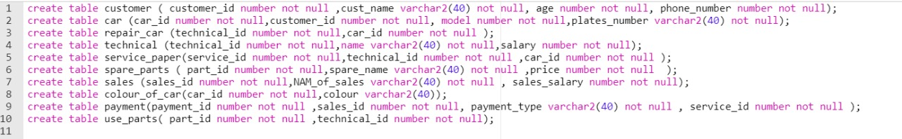

***Altering table***

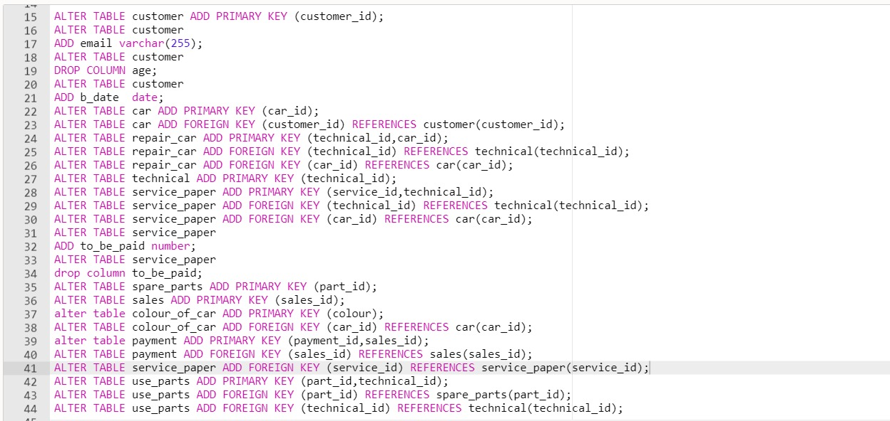

***Sample of insertion***

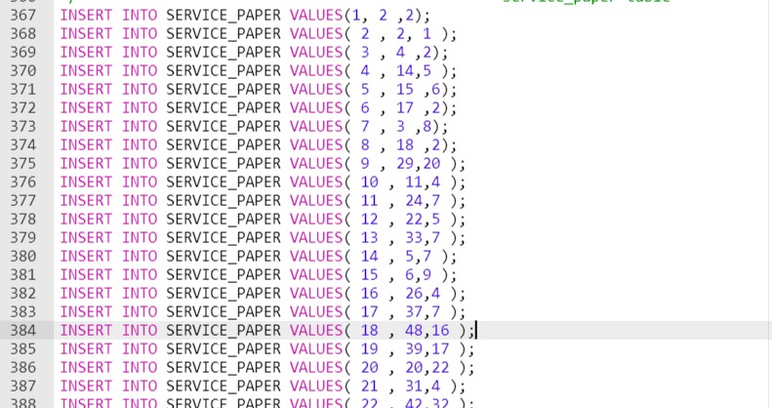

***Query:***

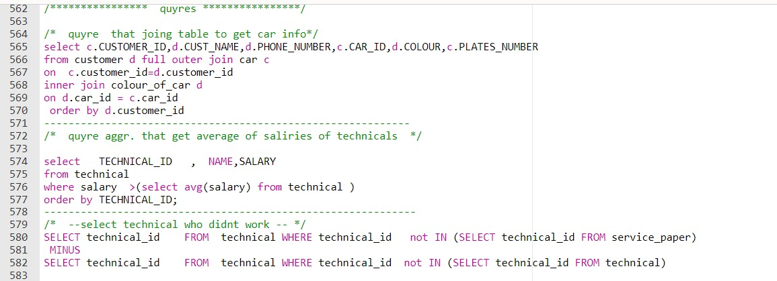

***Pl SQL:***

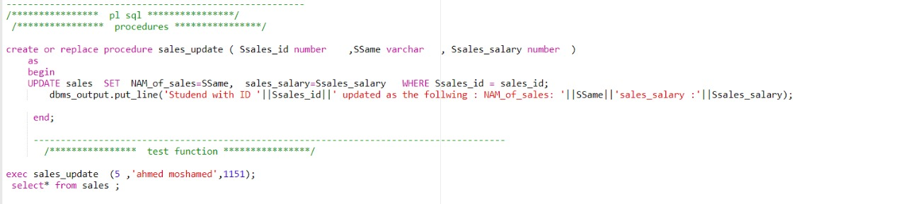

***Triggers:***

